Happy Birthday Henry!
200th Birthday of Our Special Guest Henry David Thoreau
Saturday July 8th 6:00 PM
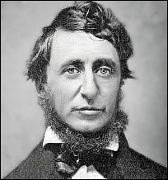

Meeting # 3,432 - Jonathan Barton
Join us as we celebrate his 200th birthday with our special guest Henry David Thoreau, one of the most famous and respected writers ever on the natural environment, liberty, and the human experiences of the 19th century.
A presentation on how his works are relevant to today's climate change movements, civil liberties struggles, and global actions for the liberation of working class peoples.
Note: A special thank you to the Massachusetts Institute of Technology for graciously sharing the use of their recently developed time travel machine in order for the speaker to attend.
College of Complexes
The Playground for People Who Think
Saturday Presentation at 6:00 PM
$3 Tuition, dinner optional
Dappers East Restaurant
2901 W. Addison (1 block west of California) Free Parking

www.collegeofcomplexes.org

