Weekly Free Speech Forum established Jan. 6, 1951

College of Complexes
The Playground for People Who Think
sustaining the academic tradition of “One Fool at a Time”

Every Saturday Main Page
at 6:00 PM www.collegeofcomplexes.org
Facebook
https://www.facebook.com/collegeofcomplexes/
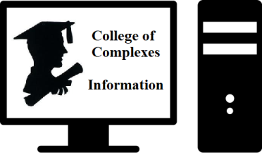

To Join the Zoom Meeting
https://us02web.zoom.us/j/81216467150

Mobile phone
1 312 626 6799, 8 121 646 7150# US (Chicago)
Landline
1 312 626 6799 US (Chicago)
Meeting ID: 812 1646 7150

To Join CoC Google Group for Updates
Send a Blank Email to:
collegeofcomplexes+subscribe@googlegroups.com

June 25th American Electoral Reform, Open Primaries, Independent Voter’s Rights
Meetings # 3,672 – Jarell Corley
Jarell Corley has been an advocate of Independent Voter’s rights for the past 10 years. He became involved with IndependentVoting.org in 2013. Since his involvement with this organization, he has acted as an advocate spokesperson for American electoral reform. Jarell canvassed his Olympia Field’s neighborhood for signatures in support of Representative John Delaney’s Open our Democracy Act in 2015. Other activities in his efforts include, fundraising, social media management, and grassroots organizing.

Presently, Jarell serves as a National Spokesperson for Open Primaries, an electoral reform organization headquartered in New York City. Open Primaries is currently building the foundation for a grassroots campaign for electoral reform here in Illinois.

Elections in our country empower a toxic political culture that is superficial and ineffective. Fortunately, the evolution of American Democracy is quietly taking shape. Independents of all beliefs and backgrounds are working for electoral reform, pushing for different initiatives all around the country. Today’s program will revolve around a few organizations playing a pivotal role in reshaping how we vote in this country.

The organization’s covered in today’s presentation include IndependentVoting.org, Open Primaries, and Veteran’s for Political Innovation. Jarell will also briefly touch on other movements fighting to shed light on the idea of electoral reform being an effective solution to solve the issue of America’s deteriorating democracy.

Information
Open Primaries Website
https://www.openprimaries.org

lIndependent Voting Website
https://independentvoting.org

Jarell’s YouTube Channel on The Independent Voter’s Movement
https://www.youtube.com/channel/UCTIwhRqM3HnD38p1NkjyWwA

July 2nd World UFO Day
75th Anniversary of the Incident at Roswell
The Extraterrestrial Event of the Millennium
Meeting # 3,673 – Charles Paidock
World UFO Day is an awareness day for people to gather together and watch the skies for unidentified flying objects (UFO).

The Roswell incident is the 1947 recovery of balloon debris from a ranch in New Mexico by US Army Air Forces officers, and the conspiracy theories, decades later, claiming that the debris was a flying saucer and that the truth had been covered up by the government.

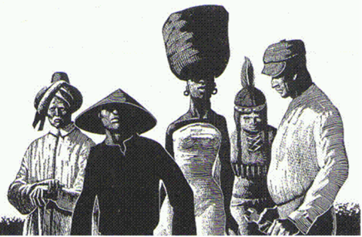
July 9th A Report / Discussion of the white supremacist
Great Replacement Theory
Illinois Young Communist League YCL
Meeting # 3,674 - Jake Chappell
Young Communists
"For democracy. For equality. For socialism. For a sustainable future and a world that puts people before profits."

The Great Replacement (French: Grand Remplacement), also known as replacement theory, is a white nationalist far-right conspiracy theory disseminated by French author Renaud Camus. The original theory states that, with the complicity or cooperation of "replacist" elites, white European populations are being demographically and culturally replaced with non-white peoples—especially from Muslim-majority countries—through mass migration, demographic growth and a drop in the birth rate of white Europeans. Since then, similar claims have been advanced in other national contexts, notably in the United States where white genocide conspiracy theories directly foment violence against nonwhite and nonchristian people as well as shape policy surrounding abortion healthcare, voting access, immigration policy, and almost every other pervasive talking point of modern US politics.
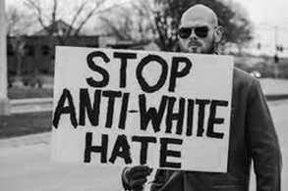
YCL website
https://youngcommunists.org /

YCL Twitter
https://twitter.com/ChicagoYCL

YCL Facebook
https://www.facebook.com/profile.php?id=100072109223577

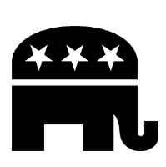
July 16th American Fascism: How the GOP is Subverting Democracy
Author, Brynn Tannehill, Transgress Press
Meeting # 3,676 - https://www.amazon.com/American-Fascism-How-Subverting-Democracy/dp/1955348030
“Trump is out of the White House, but American democracy is on the ropes and teetering on the brink of competitive authoritarianism controlled by theocrats and oligarchs. With its cherished institutions hobbled, political norms trampled, guardrails severely damaged, and body politic divided by chasms of race and geography, can the U.S. survive another administration dedicated to establishing de facto single party rule?

In this compelling, comprehensive analysis, Brynn Tannehill draws on her expertise in studying the collapse of weak democracies around the globe and her previous research in law, political science, economics and right-wing populism to explain the trajectory of how we got here and the current threats we face. Most importantly, she analyzes what the characteristics of fascism are, if they are applicable to the base of the GOP today, and what that means for us should they succeed in establishing permanent minoritarian rule. American Fascism is a surgical analysis of 250 years of

struggle for democracy in America and a prescient prognosis of what’s to come if we do not heed Tannehill’s warnings and advice.

July 23rd Chicagoland Citizens’ Climate Lobby
Meeting # 3,676 -
Citizens’ Climate Lobby is a climate change organization that exists to create the political will for a livable world by enabling individual breakthroughs in the exercise of personal and political power. Our umbrella organization, Citizens Climate Lobby, directs 600+ chapters across the U.S., Canada, and more than 30 other countries.

July 30th The Libertarian Party Platform,
as adopted by Convention, May 2022
Meeting # 3,677 - Justin Tucker, Executive Director of the Libertarian Party of Illinois
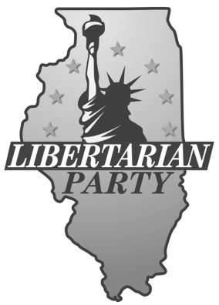
Speaker states: “As Libertarians, we seek a world of liberty; a world in which all individuals are sovereign over their own lives and no one is forced to sacrifice his or her values for the benefit of others.”

Platform: https://www.lp.org/platform/
Issues: https://www.lp.org/issues/
Libertarian Party of Illinois https://lpillinois.org/
Libertarian Party of Chicago https://www.facebook.com/groups/ChicagoLP/posts/3008396199400699/
How to Join: https://my.lp.org/contribute/join/

Aug 6, 13 Open
20, 27 Meetings # 3,678+
If you would like to speak contact the Program Coordinator Charles Paidock at (312) 842-5036, (312) 714-7790 cell, or by email to cpaidock@hotmail.com

Saturdays Presentation at 6:00 PM
To Join the Zoom Meeting
https://us02web.zoom.us/j/81216467150

By phone
1 312 626 6799, 8 121 646 7150# US (Chicago)
Meeting ID: 812 1646 7150

www.collegeofcomplexes.org

facebook: College of Complexes

https://www.facebook.com/collegeofcomplexes

Watch Videos of Previous Presentations (150+)
CoC Lecture Library
http://www.collegeofcomplexes.org/LectureLibrary.html
or go to main page for link

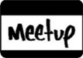
Join our Meetup Group
in order to receive weekly speaker / topic information
https://www.meetup.com/FreeSpeechForum/

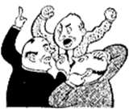
Continue Your Education All Week Long
on our electronic discussion group - to join send a blank e-mail to:
collegeofcomplexes+subscribe@googlegroups.com

